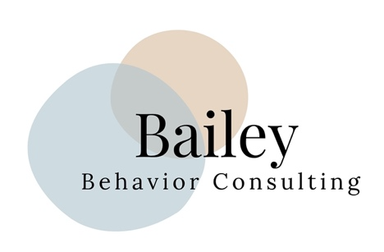

Privacy Policy

Thank you for considering Bailey Behavior Consulting LLC. We are committed to protecting your privacy and ensuring the confidentiality of your personal information. Our Privacy Policy outlines how we collect, use, and protect your personal information when you use our consulting services.

1. Collection of Personal Information

We may collect personal information from you when you use our consulting services, including your name, contact information, and other information related to you or your child’s special needs.

2. Use of Personal Information

We use your personal information solely for the purpose of providing consulting services to you. We do not share your personal information with any third parties without your consent, except as required by law.

3. Protection of Personal Information

We take all reasonable measures to protect your personal information from unauthorized access, disclosure, or misuse. We use industry-standard security measures to safeguard your personal information, including encryption and secure storage.

4. Retention of Personal Information

We retain your personal information only for as long as necessary to provide consulting services to you, or as is required by law.

5. Access to Personal Information

You may request access to your personal information at any time. If your personal information is incorrect or incomplete, you may request that it be corrected.

6. Cookies and Tracking Technologies

We use cookies and other tracking technologies to improve our website and services. Cookies are small files that are stored on your device and allow us to recognize you when you visit our website. You can disable cookies in your browser settings, but this may affect your ability to use our website and services.

7. Children’s Privacy

Our consulting services are intended for adults. We do not knowingly collect personal information from children under the age of 18.

8. Changes to Privacy Policy

We reserve the right to change this Privacy Policy at any time. Any changes will be posted on our website, and your continued use of our consulting services after the posting of such changes constitutes your acceptance of the modified Privacy Policy.

If you have any questions or concerns about our Privacy Policy, please contact me at info@baileybehaviorconsulting.com

