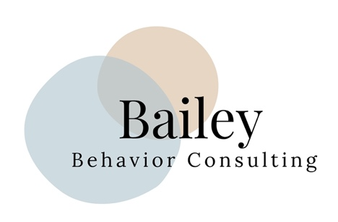

Bailey Behavior Consulting LLC is a program designed to provide resources and support to parents of children with special needs or individuals seeking behavior supports. The following legal disclosure statement is intended to inform program participants of their rights and responsibilities.

1. Program Content and Scope

The Bailey Behavior Consulting LLC program provides consulting services to parents of children with special needs or individuals seeking behavior supports. The program’s content and scope are intended to provide general support and do not constitute professional medical, legal, or financial advice. Program participants should consult with qualified professionals before making any decisions related to their child’s medical, legal, or financial well-being.

2. Consulting Relationship

The consulting relationship is based on mutual trust, respect, and confidentiality. The program’s consultants are committed to providing a safe and supportive environment for program participants. The consultant is not acting as a licensed medical, legal, or financial professional in this program and cannot provide professional advice under this model. The consultant will provided guidance and support based on their experience and expertise in the field of Applied Behavior Analysis.

3. Privacy and Confidentiality

Bailey Behavior Consulting LLC respects the privacy and confidentiality of program participants. The consultant will not share any personal information or data with third parties without the express written consent of the program participant. However, program participants should be aware that communication via the internet is not completely secure and that there is always a risk of interception or hacking.

4. Liability

Bailey Behavior Consulting LLC and its consultants are not liable for any direct or indirect damages, losses, or expenses resulting from the use of the program or services provided by the consultant. Program participants assume all responsibility for their decisions and actions related to their child’s medical, legal, or financial well-being.

5. Program Termination

Bailey Behavior Consulting LLC reserves the right to terminate the consulting relationship at any time if a program participant violates the program’s code of conduct or engages in behavior that is harmful to themselves, the consultant, or other program participants.

By participating in Bailey Behavior Consultnig LLC’s program, participants acknowledge they have read and understood this legal disclosure statement and agree to the terms and conditions outlined herein

